Group 41

POE – Part 2

Table Structures

ST10305921 – Zoe Heynke

ST103 - Panashe

Table of Contents

tblUser table 2

tblOrder table 3

tblAdmin table 4

tblClothes table 5

# tblUser table

# tblOrder table

# tblAdmin table

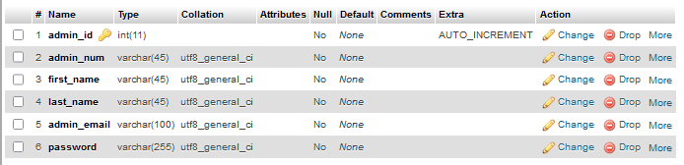

# tblClothes table

